

**CAR PARKING SENSOR**

Group 1

Names : Agung Yamora Zubara Siregar (2220010096)

Alfonda Dimas Cahaya (2220010090)

Ferdi Alwan Muhammad (2220010117)

Class : 2ISA1

**CONTINUING EDUCATION PROGRAM CENTER FOR COMPUTING AND INFORMATION TECHNOLOGY,   
FACULTY OF ENGINEERING, UNIVERSITY OF INDONESIA  
2023**

**PROJECT ON**

**CAR PARKING SENSOR**

Project Title : Implementation of IOT in Residence Gates

Batch Code : 2ISA1

Start Date : May 16, 2023

End Date : May 18, 2023

Name of Coordinator : Mr. Tri Agus Riyadi, S.Kom, MT

Names of Developer : 1. Agung Yamora Zubara Siregar

2. Alfonda Dimas Cahaya

3. Ferdi Alwan Muhammad

Date of Submission : May 19, 2023



**CERTIFICATE OF ORIGINALITY**

This is to certify that the project report titled "Car Parking Sensor" is an original work completed by Agung Yamora Zubara Siregar, Alfonda Dimas Cahaya, and Ferdi Alwan Muhammad. This project has been submitted in partial fulfillment of their course requirement at the National Institute of Information Technology (NIIT).

The project report has been prepared under authors guidance and supervision, and it is ensured that the work presented in this report is the result of the individual efforts of the aforementioned students. The contents of this report have not been submitted to any other institution or organization for the award of any degree, diploma, or other similar recognition.

Author acknowledge that the ideas, designs, and implementations presented in this project report are the intellectual properties of the students mentioned above. Any use or reproduction of this work must give proper credit to the original authors.

Author hereby endorse the authenticity and originality of the work presented in this project report and confirm that it meets the academic standards and requirements set forth by the National Institute of Information Technology (NIIT).

Coordinator :

Mr. Tri Agus Riyadi, S.Kom, MT

**ACKNOWLEDGEMENT**

Author would like to express authors deepest gratitude to everyone who contributed to the successful completion of the "Car Parking Sensor" project. First and foremost, author sincere appreciation goes to author esteemed supervisor, Mr. Tri Agus Riyadi for her invaluable guidance, support, and expertise throughout the research and development process.

Author would also like to extend author heartfelt thanks to author fellow classmates and colleagues who provided constructive feedback, suggestions, and encouragement during the course of the project. Their insights and camaraderie have been instrumental in shaping author work.

Finally, Authors are eternally grateful to author families and friends for their unwavering support, understanding, and patience during the long hours of work and study. Their belief in author abilities and the importance of this project has been a constant source of motivation and inspiration.

In conclusion, Authors acknowledge that the "Car Parking Sensor" project would not have been possible without the combined efforts of all those mentioned above. Authors are truly indebted to each and every one of them for their contributions and support.

Depok, 18 May 2023

Authors

**SYSTEM ANALYSIS**

1. I. Introduction

The Car Parking Sensor project aims to design and implement an efficient and reliable system that assists drivers in identifying available parking spaces and maneuvering their vehicles into these spaces with minimal difficulty. The project is expected to address the challenges of limited parking spaces, time-consuming parking processes, and potential accidents that may occur during parking.

1. II. System Requirements

The Car Parking Sensor system should meet the following requirements:

1. Accuracy: The system should accurately detect the presence of obstacles and measure the distance between the vehicle and these obstacles to ensure safe and efficient parking.

2. Reliability: The system should be able to operate under various environmental conditions, such as different lighting conditions, temperatures, and weather conditions, without compromising its performance.

3. Responsiveness: The system should provide real-time feedback to the driver, allowing them to make informed decisions while parking.

4. Scalability: The system should be capable of handling multiple vehicles and parking spaces simultaneously, ensuring that it can be easily integrated into larger parking facilities.

5. Cost-effectiveness: The system should be affordable and have a low maintenance cost to encourage widespread adoption.

**SYSTEM ANALYSIS**

III. System Design

The Car Parking Sensor system can be designed using a modular approach, where each component can be developed and tested independently before being integrated into the final system. The system design should consider the following aspects:

1. Sensor selection and placement

The choice of sensors and their optimal placement on the vehicle should be determined based on factors such as detection range, accuracy, and environmental robustness.

2. Microcontroller selection

A suitable microcontroller should be chosen based on its processing capabilities, memory capacity, and compatibility with the chosen sensors.

3. Signal processing

Using infrared for processing sensor data and determining the range should be developed and optimized for efficiency.

4. System integration and testing

The individual components should be integrated into a complete system, and rigorous testing should be conducted to ensure the system meets the specified requirements.

**ELECTRICAL MECHANISM**

Direct Current Voltage when sensor and buzzer idle 4.220 V

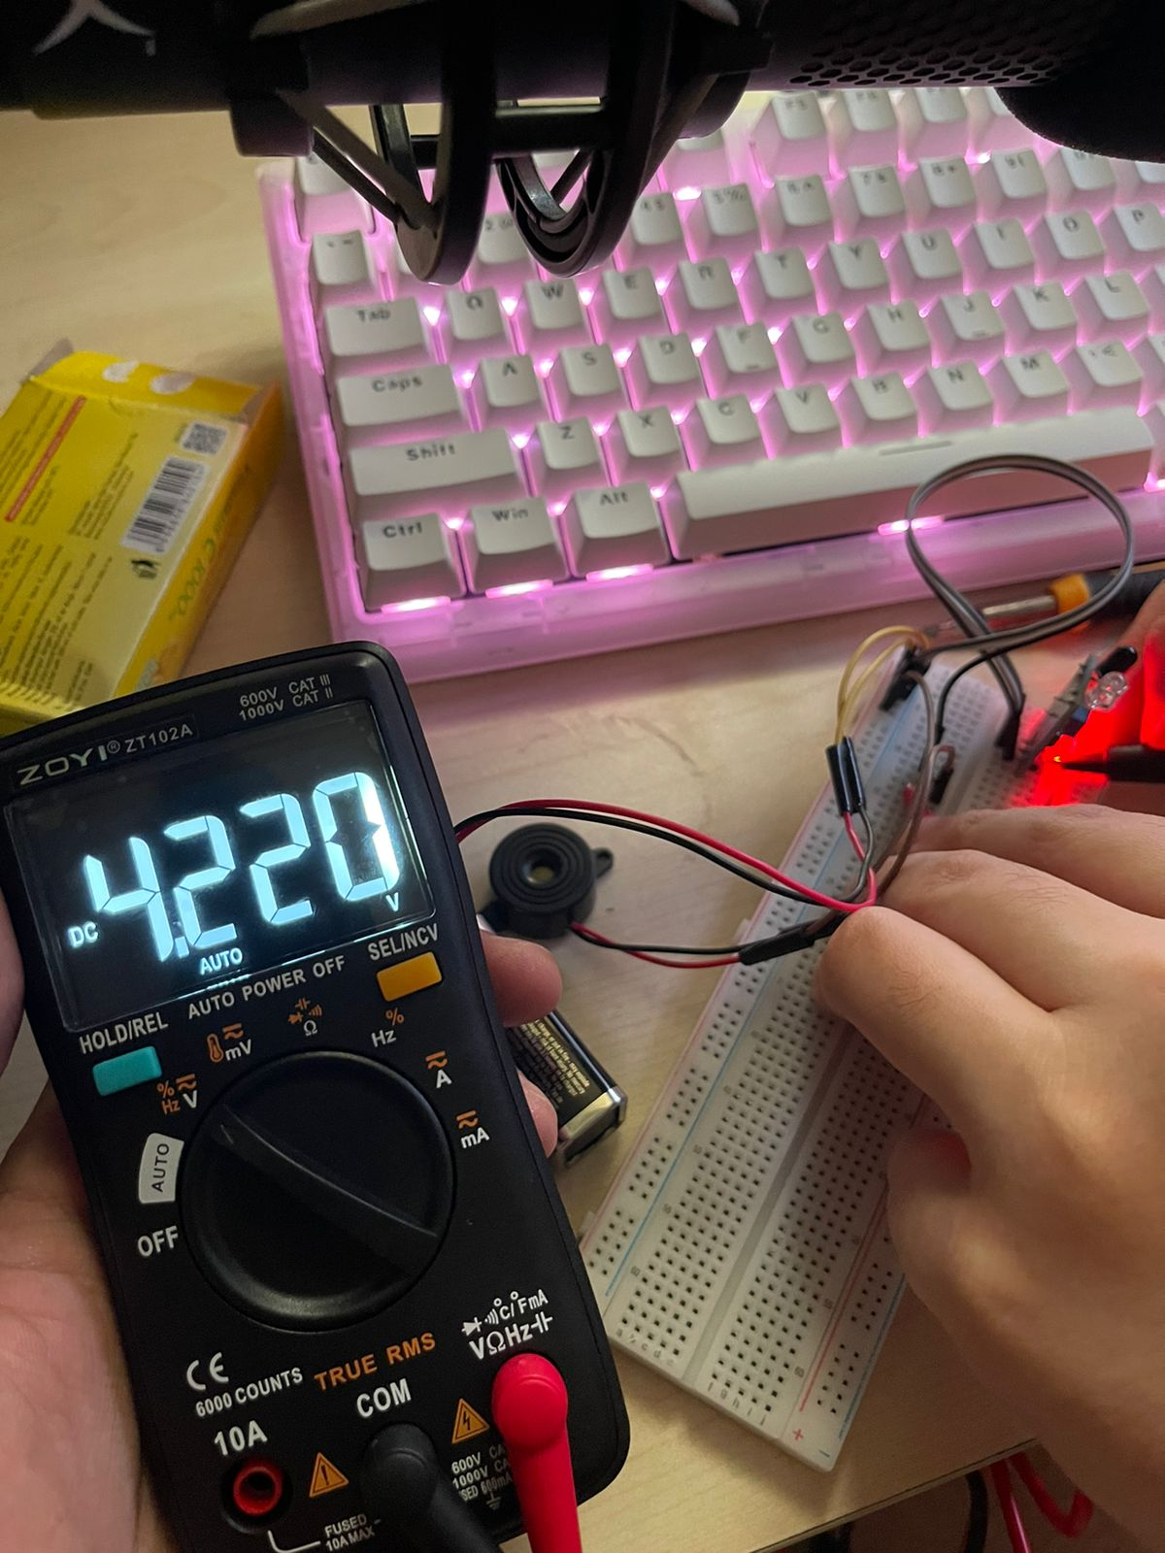

Direct Current Voltage when sensor and buzzer active 1.415 V

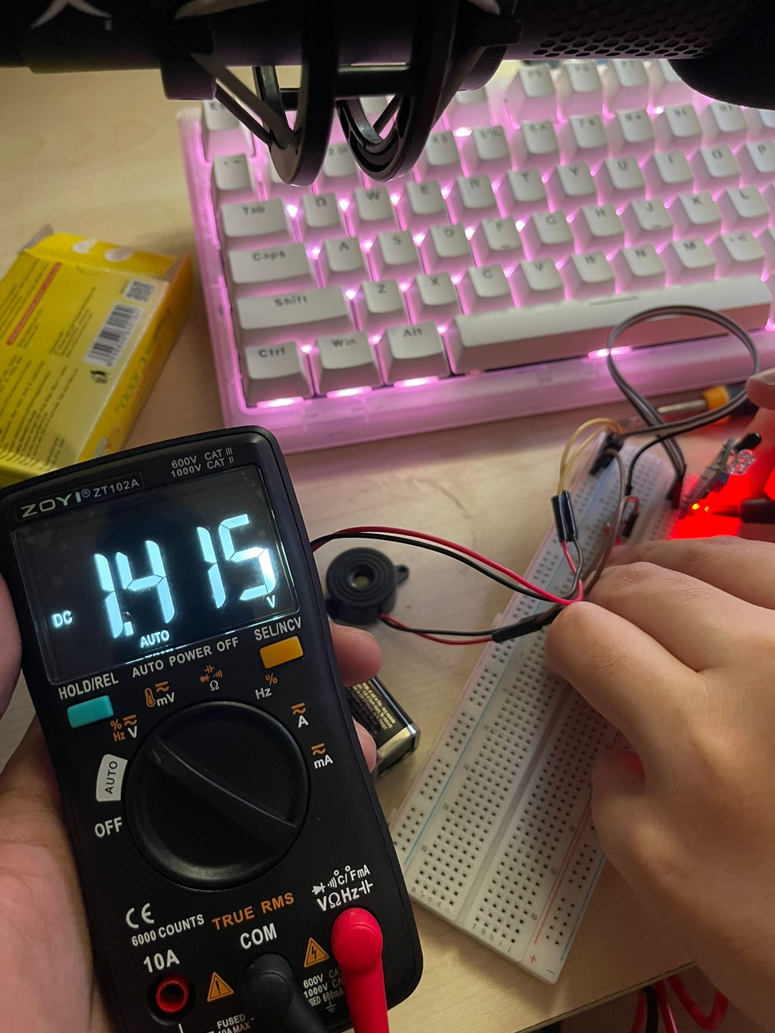

Direct Current Amperage when sensor and buzzer idle 3.16 mA

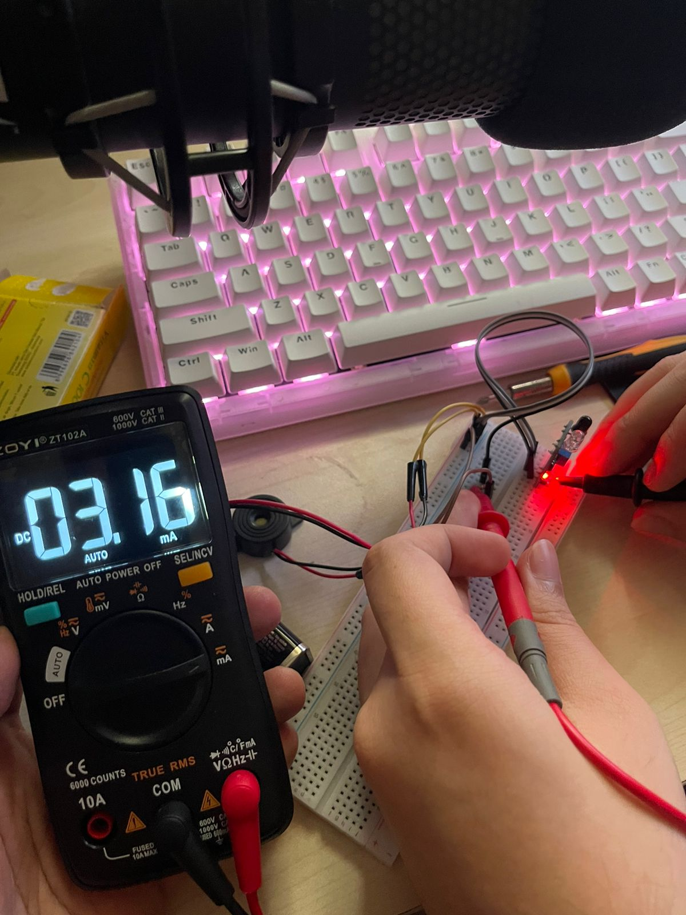

**ELECTRICAL MECHANISM**

Direct Current Amperage when sensor and buzzer active 1.98 mA

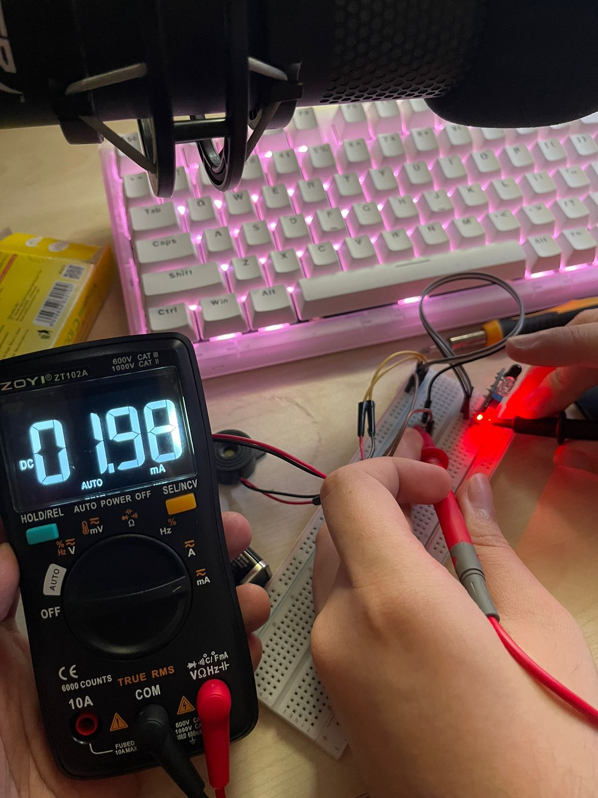

Direct Current Resistance of LM393 module was active

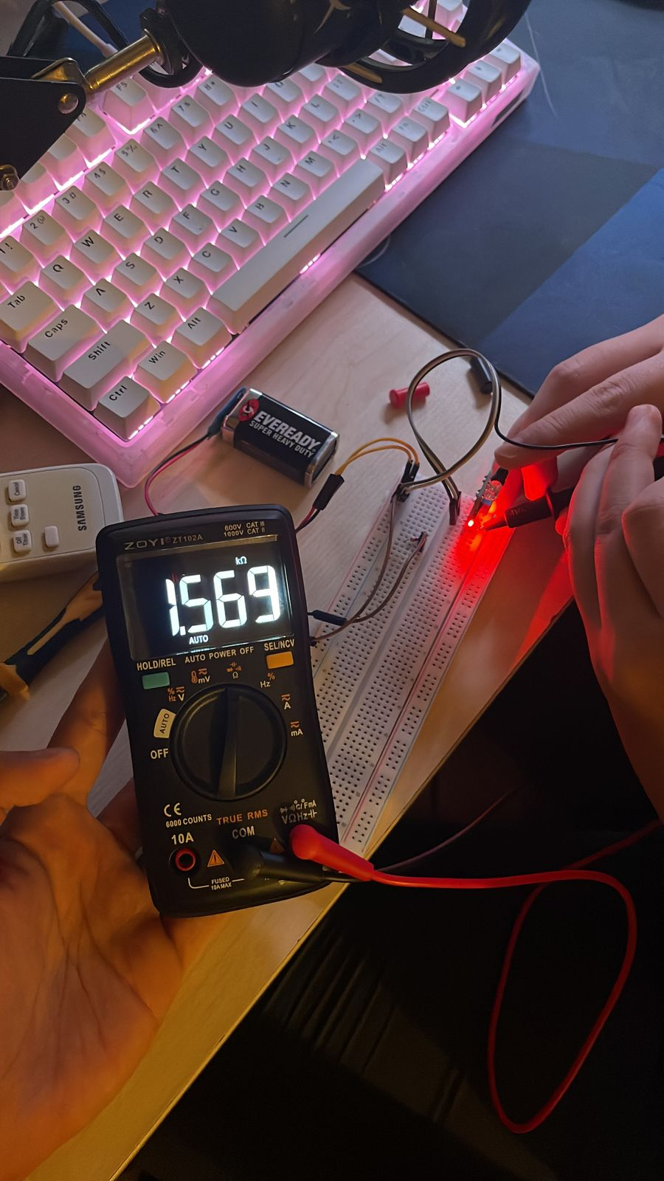

Direct Current Resistance final from LM393 through resistor buzzer

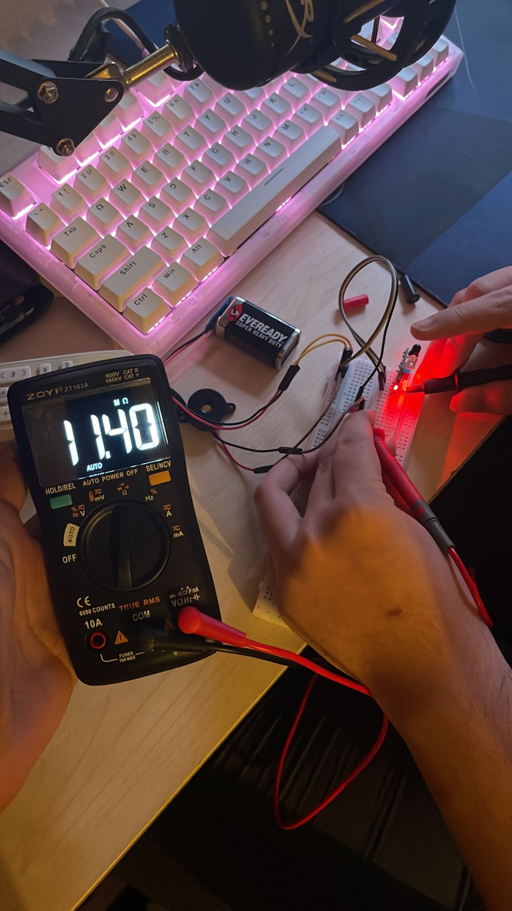

**ELECTRICAL CHARACTERISTIC**

The LM393 module that author project is a widely utilized, low-power voltage comparator that exhibits several essential electrical characteristics

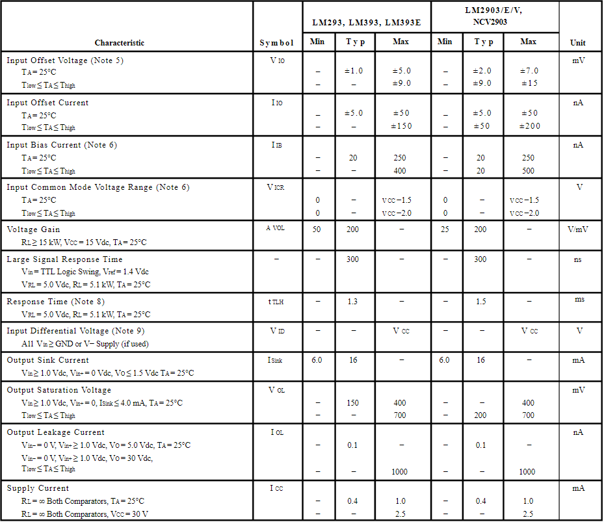

Table 1 Electrical Characteristic of LM393 Module

**CONFIGURATION**

**Hardware :**

* **IR Sensor Obstacle Avoidance Reflection**

A technique employed by infrared sensors to detect and evade obstacles by reflecting infrared light. This method enables devices, such as car or drones, to navigate their environment safely and efficiently.

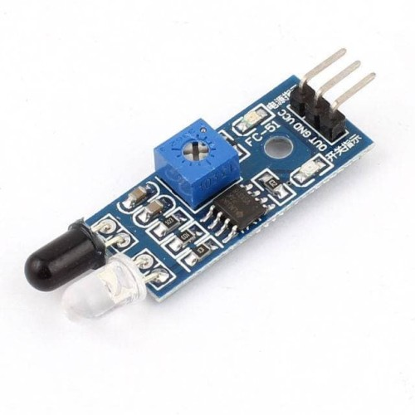

Figure 1 IR Sensor Obstacle Avoidance Reflection

* **Breadboard 830 Tie**

In simple terms, a breadboard with 830 tie-points is a tool used in Arduino projects to create temporary circuits and prototypes. It allows easy connect and disconnect components, such as sensors, LEDs, and resistors, without soldering. This enables to test and modify circuit design before finalizing it.

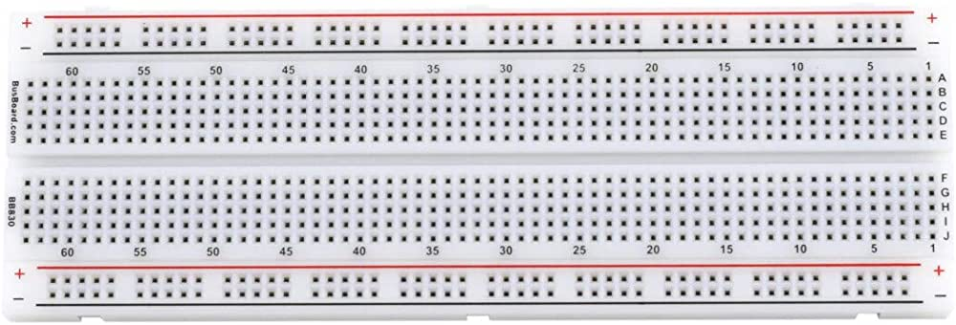

Figure 2 Breadboard 830 Tie

**CONFIGURATION**

**Hardware :**

* **Cable Male to Male**

A connector that allows for the transfer of electrical signals between two components or devices with female ports. This type of cable is often used to establish connections on a breadboard or between different modules in an Arduino project, enabling communication and data exchange between various components within the system.

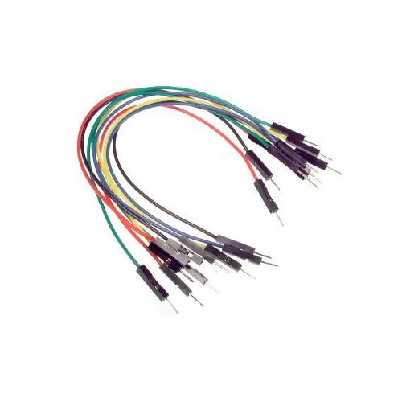

Figure 3 Cable Male to Male

* **Resistor 1 k**[Ω](https://www.google.com/search?client=opera-gx&hs=dF6&sxsrf=APwXEde8RgTTNov4vOLxf9yGhn3Xw60_3A:1684669048905&q=ohm+1+%CF%89+in&sa=X&ved=2ahUKEwjij-WhqYb_AhUT7zgGHf-UALwQ6BMoAHoECGEQAg)

A passive electronic component that serves to limit or regulate the flow of electrical current within a circuit. It has a resistance value of 1000 ohms (1 kilohm), which determines the degree to which it impedes the flow of current. The primary function of a resistor is to create a specific voltage drop or current-to-voltage relationship in a circuit, enabling the control and stabilization of electrical signals.

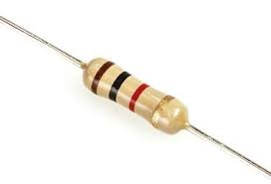

Figure 4 Resistor 1k [Ω](https://www.google.com/search?client=opera-gx&hs=dF6&sxsrf=APwXEde8RgTTNov4vOLxf9yGhn3Xw60_3A:1684669048905&q=ohm+1+%CF%89+in&sa=X&ved=2ahUKEwjij-WhqYb_AhUT7zgGHf-UALwQ6BMoAHoECGEQAg)

**CONFIGURATION**

**Hardware :**

* **Buzzer 5 V**

An electromechanical device that produces an audible sound when an electrical signal is applied. This sound is typically characterized by a continuous or intermittent buzzing noise, which serves as an alert or notification mechanism in various applications. Buzzers are commonly employed in a wide range of devices, such as alarms, timers, and electronic doorbells, to provide users with an audible indication of a specific event or condition.

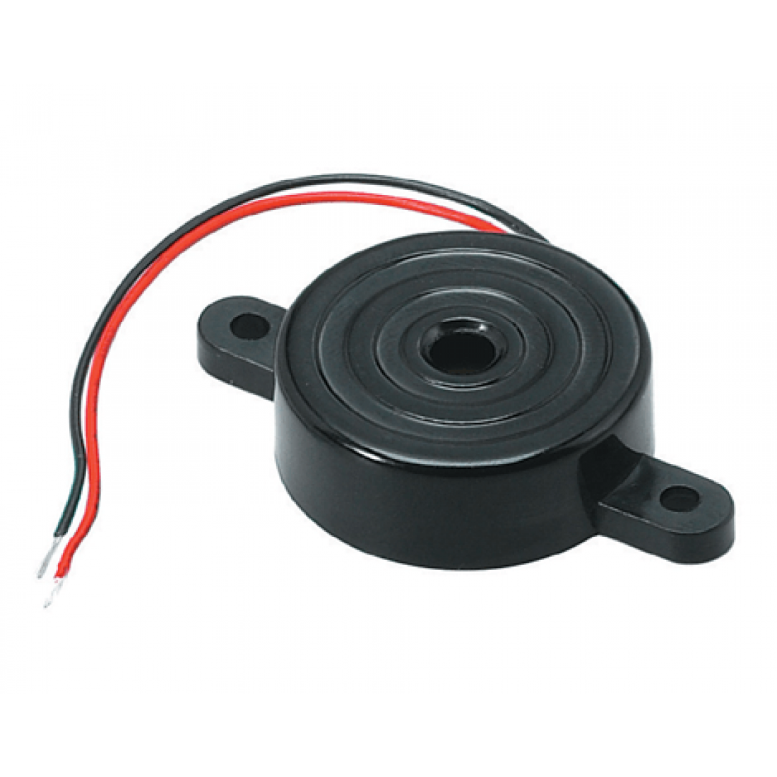

Figure 5 Buzzer 5V

* **Battery 9V and Socket**

A portable energy source that provides electrical power to various electronic devices. It consists of six individual 1.5-volt cells connected in series, resulting in a total voltage output of 9 volts and its socket to connect and provide the energy.

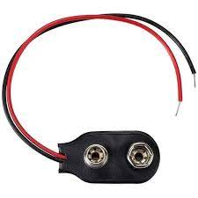

Figure 6 Battery 9V and Socket

**CONFIGURATION**

**Sketch :** Sketched in Circuit Diagram

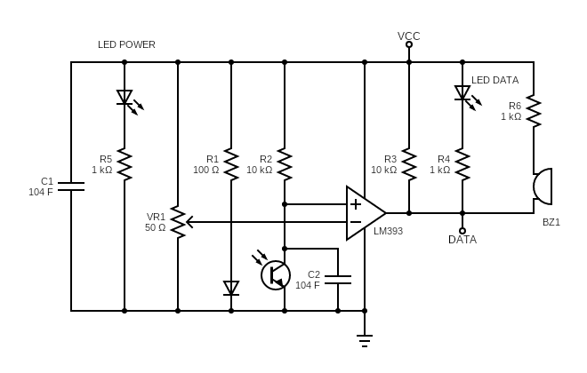

Figure 5 Circuit Diagram

**Software :**

1. Circuit Diagram
2. Ms. Word
3. Canva

**Operating System :**

Windows 11

**ADVANTAGES**

The project offers several advantages that contribute to enhancing the overall parking experience, promoting safety, and improving efficiency in various settings. Some of these advantages include:

1. Accident prevention: The primary benefit of a car parking sensor system is the reduction in the likelihood of accidents. By providing real-time feedback on the proximity of obstacles, drivers can avoid collisions and potential damage to their vehicles, as well as other cars or property.

2. Enhanced safety: The implementation of parking sensors increases safety for pedestrians and other road users who may be at risk of being hit by vehicles in parking lots or tight spaces. This technology ensures that drivers are more aware of their surroundings, thus minimizing the risk of injury.

3. Improved parking efficiency: Car parking sensors enable drivers to park more accurately and quickly, which can lead to better utilization of parking spaces and reduced congestion in parking lots. This is particularly beneficial in urban areas where parking spaces are limited and in high demand.

4. Increased driver confidence: The real-time feedback provided by parking sensors can boost driver confidence, particularly for those who may be anxious about parking in tight spaces. This can lead to a more enjoyable and stress-free driving experience.

5. Reduced insurance costs: By minimizing the risk of accidents and damage to vehicles, car parking sensors can help drivers maintain a clean driving record. This, in turn, may result in lower insurance premiums.

**DISADVANTAGES**

Despite the potential benefits of a Car Parking Sensor project, there are several disadvantages that must be considered:

1. High Installation Costs: Implementing parking sensors in a car park requires substantial investment in terms of purchasing the sensors, wiring, and control systems. This may be a deterrent for some car park owners or operators who are unwilling or unable to invest in such technology.

2. Maintenance Requirements: Parking sensors are electronic devices that are exposed to harsh environmental conditions, such as dust, moisture, and extreme temperatures. Consequently, may require regular maintenance and replacement, which can contribute to ongoing operational costs

3. Limited Detection Capabilities: While parking sensors can effectively detect obstacles within their range, may not be able to detect all types of obstacles, such as small objects or those with irregular shapes. This limitation might result in false alarms or undetected obstacles, posing potential safety risks.

4. Technological Obsolescence: As technology advances rapidly, the parking sensors currently available may become outdated in a few years, necessitating upgrades or replacements. This could lead to additional costs for car park owners and operators.

**CONCLUSION**

The Car Parking Sensor project seeks to create a dependable, accurate, and user-friendly solution that overcomes the problems associated with parking in congested urban locations. The project has the potential to considerably improve the parking experience for drivers and contribute to more efficient use of limited parking spots by using a modular design approach and taking into account the varied system needs.

Furthermore, by reducing traffic congestion and emissions caused by time-consuming parking searches, the project helps to the larger goal of developing smarter, more sustainable communities. As global urbanization increases, the "Car Parking Sensor" project is a significant and timely venture that merits additional research and development to maximize its performance and scalability across varied contexts.